ECE 441 Fall 2021

WEEK #9/10 GROUP MEETING LOG

Lab Session: 2

Group Number: 2

Instructor: Dr. Jafar Saniie

Due Date: 03-23-2022

Acknowledgment: I acknowledge all of the work (including figures and codes) belongs to me and/or persons who are referenced.

Member 1: Alan Palayil

Member 2: Fabian Garcia

Member 3: Gabriel Gutierrez

[Smart Mirror - *Through the Speculum*]

**Project Goal:**

* Create an interactive smart mirror with gesture control, voice commands, and possibly facial recognition.
* Include accessories like LED strips and a sound system.
* Design a compacted design for the 24inch display

**Standards used in Project:**

Not applicable during this stage of the project

**System Constraints:**

* Xbox Kinect is meant for windows/microsoft devices; however, some additional libraries can be installed to the raspberry pi to help run this device.
* There is currently no operational wake engine for alexa voice services

**Prior Knowledge Acquired Critical to Design Project:**

ECE 100, ECE 211, ECE 213, ECE 218, ECE 242, ECE 307, ECE 308, ECE 311, ECE 319, ECE 407, ECE 411, ECE 436, ECE 438, ECE 485, CS 115, CS 116, CS 330, CS 331, CS 350, CS 351, CS 450

Note:

CS 331- Data Structures and Algorithms (Python Programming)

ECE 411: Power Electronics

Meeting 1

| Date | 3/19/2022 |
| --- | --- |
| Start Time | 12:00 PM |
| Duration | 1:30 hour |
| Attendance | All attended |

1. **Agenda**

Discuss progress made over spring break and any setbacks or challenges that have arisen

**Fabian:**

I successfully installed and ran OpenCV. I moved forward and shifted my focus onto the Kinect and the integration with Raspbian. I ran into some trouble and spent a few hours trying to troubleshoot the error.

The kinect is being recognized by the Raspberry Pi, however, I can’t run the test for freenect2 that displays the multiple images from the kinect; IR, depth, and color. The window that is supposed to be created does not pop up and the above errors are returned. I looked at the official forum for freenect2. I have found similar issues, but the fix that is suggested does not solve the issue that I am having. 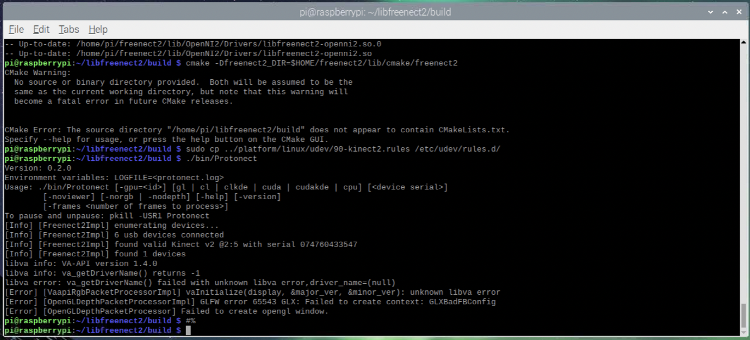

**Gabriel:**

After receiving the RaspberryPi 4 B, OpenCV was also successfully installed to begin testing the photobooth applications.

Two programs were initially tested, the [All-seeing PI photobooth](https://www.raspberrypi.com/news/all-seeing-pi-photo-booth/) and the [OpenCV_Raspberry_pi_TBB](https://github.com/abhiTronix/OpenCV_Raspberry_pi_TBB); however, both these programs were unsuccessful.

A different github repository was found that will be tested.



**Alan:**

After assembling the IR frame, the module integration for touch screen on the magic mirror was set up. I also completed the configuration of Spotify on the Magic Mirror to make the mirror a stand alone device.

1. **Tasks**

| **1 - Idea development** | | |
| --- | --- | --- |
| **Task** | **Assigned to** | **Due Date** |
| Freenect2 | Fabian | TBD |
| Implement to Snapchat filter program | Gabriel | Next meeting |
| Touch Screen | Alan | Completed |
| User Interface and LED integration | Alan | 3/27 |

1. **Work Distribution**

| **Alan Palayil** | Completed the touch screen interface and now starting to work on User Interface and LED integration. |
| --- | --- |
| **Fabian Garcia** | I will continue to work on troubleshooting freenect2 |
| **Gabriel Gutierrez** | Tested 2 snapchat filters |

1. **Progress and Milestones**

We have all successfully installed OpenCV and were able to begin with the photobooth function. We were able to use some filters through OpenCV.

1. **Next Steps**

The primary focus will be to try and get freenect2 working so we can continue moving forward with the design.

Next meeting: 3/23/2022

Meeting 2

| Date | 3/21/2022 |
| --- | --- |
| Start Time | 1:00 PM |
| Duration | 2:00 hour |
| Attendance | All attended |

1. **Agenda**

**Fabian:**

Spending some more time with freenect2, I have not been able to solve the issue. I have uninstalled some drivers and reinstalled them. I have tried starting freenect2 from scratch and have gone as far as trying freenect on a clean install of raspbian. The Kinect is still recognized by the Raspberry Pi but no window pop ups to test the video. I tried pulling the video or picture input from the camera, but I am not able to get any images or video. Through testing however, running ./bin/Protonect as instructed by the libfreenect github does not create a window. However, running “./bin/Protonect cpu”, turns the Kinect on but still does not open the necessary windows.

**Gabriel**

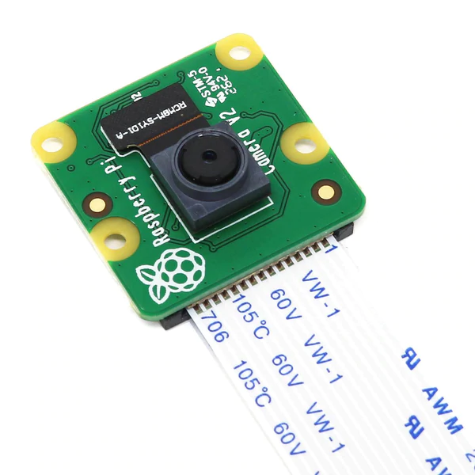

The new snapchat filter/photo booth is successfully up and running on the raspberry pi. A camera module is used as the opencv face capture device.

The following is an example of the acquired filter.

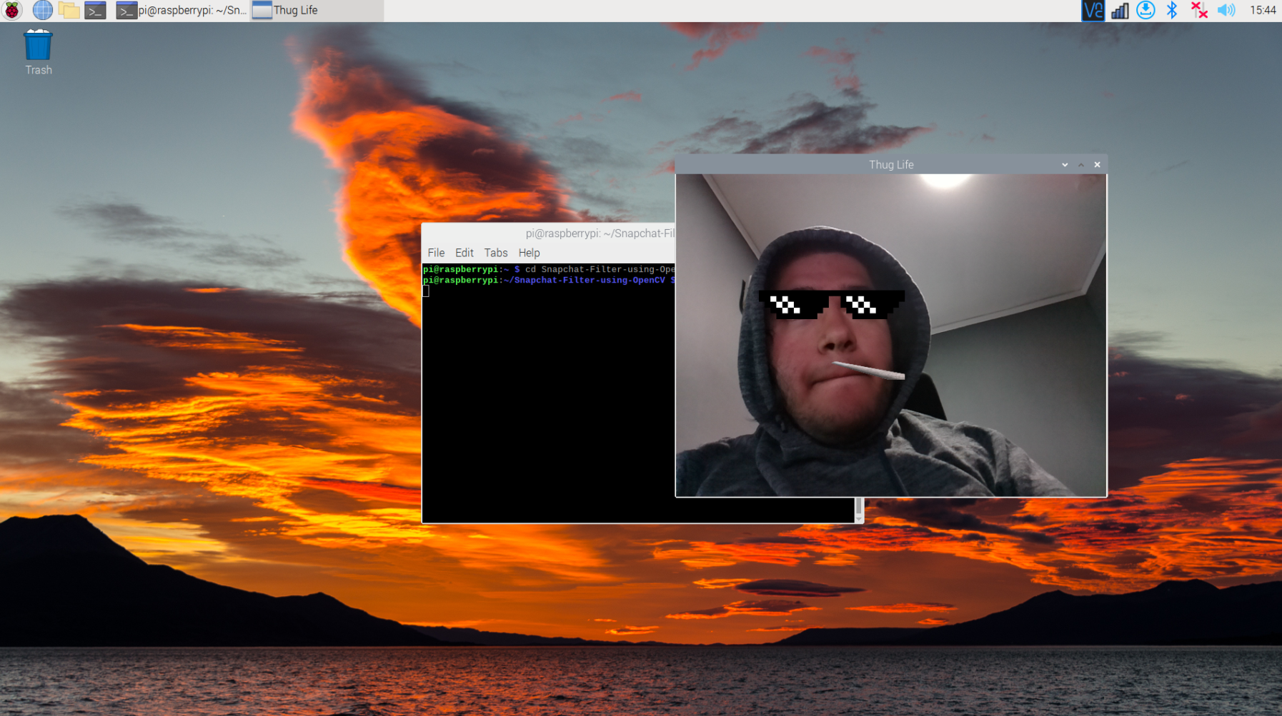

With this program up and running, we will figure out how to add it to the magic mirror software so it runs simultaneously.

Since this github repository only has 3 face filters, some additional ones will be added such as a dog, cat, rabbit, etc.. will be added.

**Alan:**

Started working on the user interface to align the modules for the most user friendly experience. I am working on casting apps on the mirror which can be used for casting workout videos and youtube or your mobile screen.

1. **Tasks**

| **1 - Idea development** | | |
| --- | --- | --- |
| **Task** | **Assigned to** | **Due Date** |
| freenect | Fabian |  |
| Add more filters | Gabriel |  |
| Add filter program to magic mirror | Gabriel/Alan |  |
| Casting video | Alan | 3/29 |
|  |  |  |

1. **Work Distribution**

| **Alan Palayil** | Work on the video casting and LED integration. |
| --- | --- |
| **Fabian Garcia** | Will continue troubleshooting. If unsuccessful we will exchange the Kinect and see if any of us has better luck. |
| **Gabriel Gutierrez** | Successfully got a snapchat filter running |

1. **Progress and Milestones**

The team has successfully ran a photobooth/snapchat filter program and the IR touch screen is also fully functional.

1. **Next Steps**

The next steps is to debug the kinect to raspberry pi program, and work on the smart mirror’s UI.

Our next meeting will be Saturday the 26th.